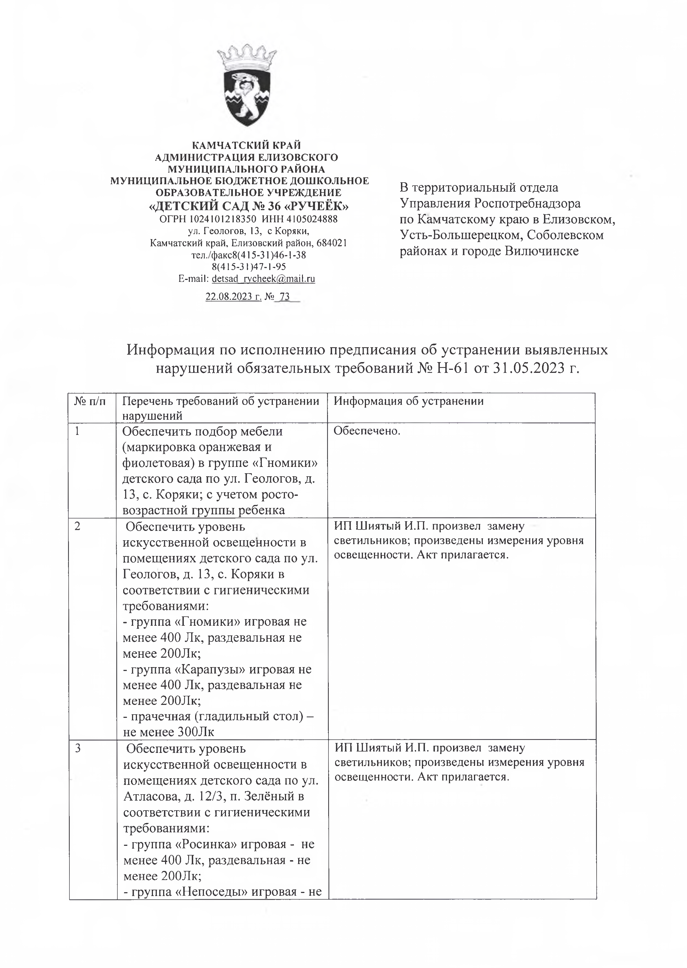

|  |  |  |
| --- | --- | --- |
|  |  |  |
|  |  | . |
|  |  |  |
| 3 |  |  |

|  |  |  |
| --- | --- | --- |
|  |  |  |
|  |  |  |
|  |  |  |
|  |  |
|  |  |
|  |  |
|  |  |
|  |  |
|  |  |
|  |  |
|  |  |
|  |  |
|  |  |
|  |  |
|  |  |
|  |  |  |
|  |  |  |
|  |  |  |
|  |  |  |

